AirSense Web Based Climate & Air Quality Monitoring

A PROJECT REPORT [HACKATHON REPORT]

Submitted by

SHEIK SHAARIQ SHEIK MUSTHAK [RA2311056010276]
SHREYANSH KUMAR [RA2311050010084]
ROSHAN KUMAR JHA [RA2311003012371]

in partial fulfillment for the hackathon requirements of

SAMSUNG INNOVATION CAMPUS


SRM INSTITUTE OF SCIENCE AND TECHNOLOGY

KATTANKULATHUR- 603 203

JUNE 2026

ABSTRACT
Air pollution has emerged as one of the most critical environmental and public health challenges worldwide, particularly in rapidly urbanizing regions. Increasing levels of particulate matter and harmful gaseous pollutants have significant impacts on human health, ecosystems, and overall quality of life. Continuous monitoring, effective data analysis, and timely dissemination of pollution information are therefore essential for environmental agencies, researchers, and the general public. However, raw environmental sensor data often contains missing values, inconsistent formats, sensor faults, and anomalous readings that must be addressed before meaningful analysis can be performed.
This project presents a comprehensive Climate & Air Quality Monitoring System that implements a complete end-to-end air quality data processing pipeline. The system begins with an automated Extract, Transform, and Load (ETL) process that generates and processes hourly air quality data for ten major Indian metropolitan cities. The ETL pipeline performs extensive data cleaning by handling missing values, correcting inconsistent data formats, removing sensor faults, normalizing city names, detecting and capping abnormal sensor spikes, and computing a standardized Air Quality Index (AQI) using multiple atmospheric pollutants, including PM2.5, PM10, NO₂, SO₂, CO, and O₃. The cleaned dataset is then exported for further analysis and visualization.
To identify hazardous pollution events, the project incorporates fundamental Data Structures and Algorithms (DSA) concepts through the implementation of a custom Stack and Priority Queue without relying on external libraries. Pollution alerts are generated whenever the AQI exceeds critical thresholds and are first stored using a stack before being prioritized according to pollution severity. The system further identifies continuous three-hour critical pollution windows for individual cities, enabling authorities to recognize prolonged exposure periods that may require immediate intervention.
The processed data is then analyzed using an interactive Climate Dashboard developed with Matplotlib. The dashboard presents multiple analytical visualizations, including hourly AQI trends across cities, temporal heatmaps illustrating pollution variation throughout the week, grouped comparisons of normalized pollutant concentrations across AQI categories, and city-wise AQI distribution through pie charts. These visualizations provide valuable insights into pollution patterns, pollutant dominance, and regional air quality conditions.
To enhance geographical understanding of pollution distribution, the project integrates Folium to create an interactive AQI Risk Map for Indian metropolitan cities. The map utilizes color-coded markers based on pollution severity, dynamic pop-up windows displaying city-specific environmental statistics, and heatmap overlays that highlight regions with elevated pollution levels. Users can interactively explore air quality conditions across different cities and identify pollution hotspots through an intuitive geographic interface.
To improve usability and accessibility, the complete system is deployed as an interactive Streamlit web application. The web interface consolidates all project components into a unified platform featuring multiple navigation pages for the cleaned dataset, climate analytics dashboard, pollution alert system, and AQI risk map. Interactive tables, performance metrics, downloadable datasets, and real-time visualizations significantly enhance the overall user experience while demonstrating the practical application of data science techniques in environmental monitoring.
Overall, this project demonstrates the successful integration of data engineering, data structures, data visualization, geospatial analysis, and web application development into a single environmental monitoring platform. The developed system provides an efficient framework for analyzing air quality data, detecting hazardous pollution conditions, and presenting environmental information in a user-friendly manner. The modular design of the application also enables future enhancements such as real-time IoT sensor integration, machine learning-based AQI prediction, cloud deployment, weather data fusion, and automated notification systems, making it a scalable solution for next-generation smart environmental monitoring.

OBJECTIVES

The objectives of the project are:

- Develop an automated ETL pipeline for air quality datasets.
- Handle missing values and sensor anomalies.
- Compute Air Quality Index (AQI).
- Detect critical pollution alerts using Data Structures.
- Visualize pollution trends using statistical charts.
- Build an interactive AQI Risk Map.
- Deploy an interactive web application using Streamlit.

PROBLEM STATEMENT
Air pollution has become one of the most significant environmental and public health concerns in modern urban areas. Rapid industrialization, increasing vehicular emissions, construction activities, and population growth have resulted in deteriorating air quality across many Indian cities. Exposure to pollutants such as Particulate Matter (PM2.5 and PM10), Nitrogen Dioxide (NO₂), Sulphur Dioxide (SO₂), Carbon Monoxide (CO), and Ozone (O₃) can lead to severe respiratory illnesses, cardiovascular diseases, reduced life expectancy, and significant environmental degradation. Therefore, continuous monitoring and timely analysis of air quality have become essential for protecting public health and supporting environmental policy decisions.
Although numerous air quality monitoring stations continuously collect atmospheric data, the raw data obtained from these sensors often contains several inconsistencies and quality issues. Missing observations, invalid timestamps, sensor malfunctions, inconsistent data formats, abnormal sensor spikes, and incorrect pollutant readings frequently occur due to hardware failures, communication interruptions, calibration errors, or environmental interference. Such data cannot be directly used for analysis or decision-making without undergoing extensive preprocessing and validation.
Traditional systems generally lack automated mechanisms for data cleaning, pollutant prioritization, intelligent alert generation, and interactive visualization. As a result, environmental analysts and decision-makers must spend considerable time manually interpreting raw data before meaningful conclusions can be drawn. Furthermore, conventional reports provide limited geographical context and often fail to communicate pollution severity effectively to the public or regulatory authorities.
Another major challenge is the identification and prioritization of hazardous pollution events. Merely displaying pollutant concentrations does not provide sufficient information regarding which locations require immediate attention. Environmental agencies require mechanisms capable of automatically detecting critical AQI levels, ranking pollution alerts based on severity, and identifying continuous periods of hazardous air quality that may indicate prolonged exposure risks. Without automated alert prioritization, emergency response and preventive actions may be delayed.
Effective visualization also plays a vital role in environmental monitoring. Large volumes of hourly air quality measurements collected across multiple cities are difficult to interpret using numerical tables alone. Additionally, geospatial representation of pollution data enables users to quickly recognize pollution hotspots and understand regional variations in air quality.
To address these challenges, this project develops a comprehensive Climate & Air Quality Monitoring System that integrates data engineering, data structures, visualization, and web technologies into a single platform. The system begins by generating and processing hourly air quality data for ten major Indian metropolitan cities. A robust Extract–Transform–Load (ETL) pipeline cleans and standardizes the dataset by handling missing values, correcting inconsistent pollutant formats, replacing faulty sensor readings, normalizing city names, removing invalid timestamps, and detecting abnormal sensor spikes before computing the Air Quality Index (AQI).
After preprocessing, the system implements custom Stack and Priority Queue data structures to detect hazardous pollution events, rank alerts according to AQI severity, and identify continuous three-hour critical pollution windows for each city. These algorithms provide an efficient mechanism for prioritizing pollution alerts and supporting timely environmental response.
To improve data interpretation, the processed information is presented through a comprehensive Climate Dashboard developed using Matplotlib, containing multiple analytical visualizations including AQI trend analysis, temporal heatmaps, grouped pollutant comparisons, and city-wise AQI distribution charts. An interactive AQI Risk Map, developed using Folium, further enhances spatial understanding by displaying pollution severity through color-coded markers, heatmap overlays, and informative city-specific popups.
Finally, the complete system is deployed as an interactive Streamlit web application, providing a centralized platform where users can explore cleaned datasets, analyze pollution trends, monitor critical alerts, and visualize geographical pollution patterns. By integrating automated data preprocessing, intelligent alert generation, statistical visualization, geospatial mapping, and an intuitive web interface, the proposed solution offers a practical, scalable, and user-friendly framework for modern air quality monitoring and environmental decision support.

TECHONOLOGIES USED

Programming Language
- Python
Libraries
- Pandas
- NumPy
- Matplotlib
- Folium
- Streamlit
- Streamlit-Folium
Concepts
- ETL Pipeline
- Data Cleaning
- Stack
- Priority Queue
- Interactive Dashboard
- GIS Mapping
Development Environment
- VS Code
- Streamlit

SYSTEM ARCHITECTURE

Raw AQI Data
│
▼
ETL Pipeline
│
▼
Clean Dataset
│
├─────────────┐
▼ ▼
Alert System Dashboard
│ │
└──────┬──────┘
▼
AQI Risk Map
│
▼
Streamlit Dashboard

TASK 1 – AQI Data Pipeline (Pandas + ETL)

Introduction
Environmental monitoring systems collect enormous amounts of air quality data from multiple sensors deployed across various cities. However, raw sensor data is rarely suitable for immediate analysis due to missing values, inconsistent formatting, sensor failures, and abnormal measurements. Such issues reduce data reliability and may lead to incorrect conclusions if not handled properly.
The objective of Task 1 was to develop a complete Extract–Transform–Load (ETL) pipeline capable of cleaning and standardizing hourly air quality data before further analysis. The ETL pipeline ensures that all downstream analytics, visualizations, and pollution alerts operate on a high-quality dataset.
Dataset Generation
Unlike traditional projects that rely on external datasets, the hackathon provided starter code that programmatically generated hourly AQI observations for ten major Indian metropolitan cities.
The generated dataset consisted of the following attributes:
- Timestamp
- City
- PM2.5
- PM10
- NO₂
- SO₂
- CO
- O₃
Additionally, several artificial data quality issues were deliberately injected into the dataset to simulate real-world environmental sensor problems.

Data Quality Issues
The generated dataset contained multiple anomalies including:
- Missing PM2.5 values
- PM10 values stored with the unit "µg/m³" instead of numeric values
- CO sensor faults represented by -9999
- Mixed uppercase and lowercase city names
- Missing timestamps
- Missing SO₂ values
- Extreme PM2.5 sensor spikes (9999)
These issues prevented direct analysis and required systematic preprocessing.

Missing Value Handling
Missing values are common in environmental monitoring due to temporary communication failures, maintenance activities, or malfunctioning sensors.
The following strategy was adopted:
PM2.5
Missing PM2.5 values were replaced using the city-wise mean concentration.
Using city-specific statistics preserves local pollution characteristics instead of introducing a global average.
CO
Sensor faults represented by -9999 were first converted into missing values.
The missing values were then replaced using the city-wise median because median values are more robust against outliers.
SO₂ and NO₂
Any missing values present after conversion were also replaced using city-wise median concentrations.
This ensured that no pollutant column contained missing values before AQI calculation.

PM10 Cleaning
Some PM10 observations were stored as:
180.3 µg/m³
instead of
180.3
Since mathematical operations cannot be performed on strings, the ETL pipeline:
- Removed the "µg/m³" suffix.
- Converted the remaining values into floating-point numbers.
This transformation converted all PM10 observations into numerical format suitable for analysis.

CO Sensor Error Removal
Several CO measurements contained the value:
-9999
This value represents a sensor malfunction rather than an actual pollutant concentration.
The ETL pipeline:
- Identified every occurrence of -9999.
- Replaced it with NaN.
- Filled the missing values using the city-wise median.
This approach prevented sensor faults from influencing AQI calculations.

City Name Normalization
The dataset intentionally contained inconsistent city names such as:
- delhi
- DELHI
- Delhi
Such inconsistencies create duplicate groups during aggregation.
The ETL pipeline standardized every city name using Title Case, ensuring that all records belonging to the same city were grouped correctly.

Handling Sensor Spikes
Three PM2.5 readings contained an abnormal value of 9999.
These values were unrealistic and represented sensor spikes.
Instead of removing these observations entirely, the values were capped to the 99th percentile of valid PM2.5 observations.
This technique preserves the records while preventing extreme values from dominating statistical analysis.

AQI Calculation
After cleaning, the Air Quality Index (AQI) was computed using the following formula:
AQI = max(PM2.5, PM10, NO₂/2, SO₂, CO × 10, O₃/2)
This formula identifies the pollutant contributing the highest health risk at a particular time and uses it as the AQI value.
The computed AQI was then categorized into standard pollution levels:
- Good
- Satisfactory
- Moderate
- Poor
- Very Poor
- Severe
Additionally, a Rush Hour flag was created by identifying observations recorded during typical traffic hours.

Exporting the Clean Dataset
The cleaned dataset was exported as:
daily_aqi.csv
This dataset served as the primary input for:
- Pollution Alert System
- Climate Dashboard
- AQI Risk Map
- Streamlit Web Application

Output
The ETL pipeline successfully transformed noisy environmental data into a structured, consistent, and analysis-ready dataset.
Insert Figure
Figure 1.1: Cleaned AQI Dataset
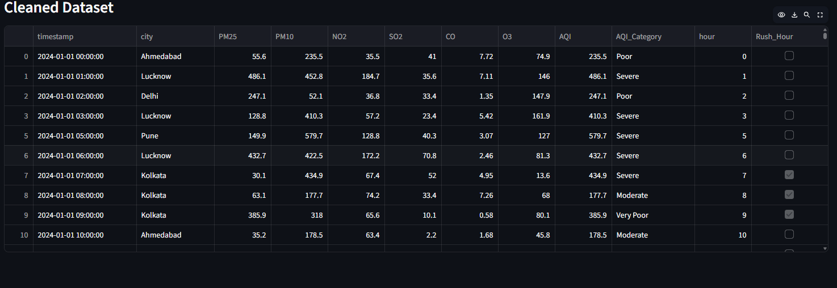

Figure 1.2: ETL Completion Output

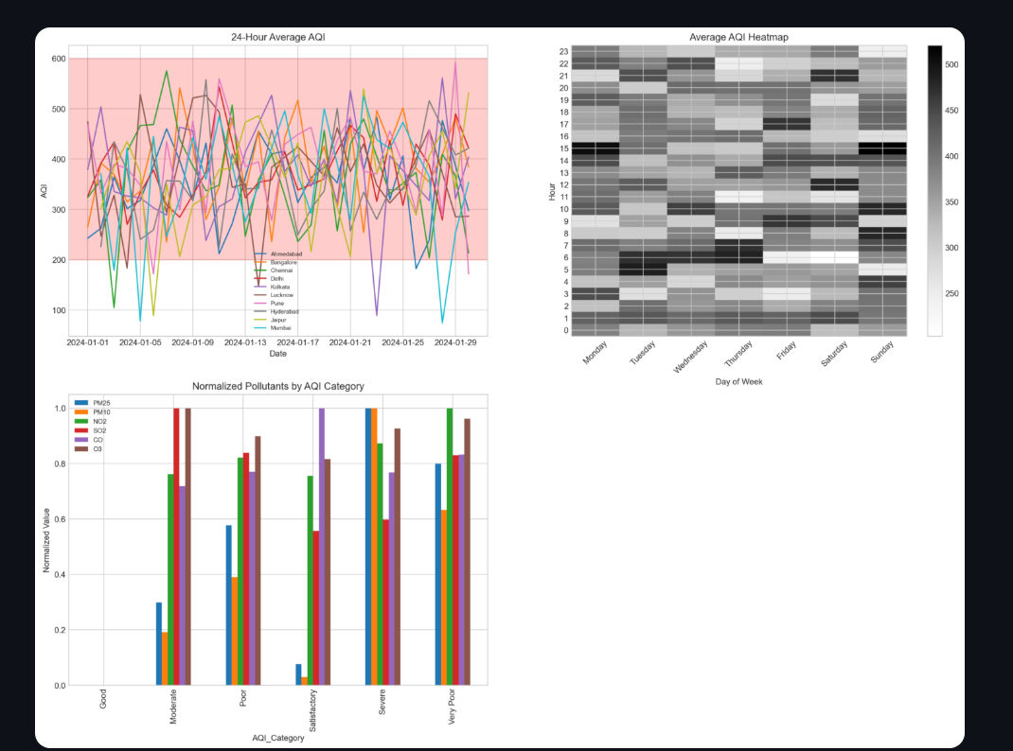

TASK 2 – Pollution Alert System (Stack + Priority Queue)
Introduction
Environmental agencies must respond rapidly whenever pollution reaches hazardous levels. Merely storing AQI values is insufficient because authorities need to identify the most critical locations requiring immediate intervention.
Task 2 implements a real-time pollution alert system using two fundamental Data Structures:
- Stack
- Priority Queue
The implementation was performed completely from scratch without using external libraries.

Stack Implementation
A custom Stack class was developed implementing the following operations:
- Push
- Pop
- Peek
- Is Empty
Whenever an AQI value exceeded 200, an alert object containing:
- City
- Timestamp
- AQI
was pushed onto the stack.
The stack temporarily stored all hazardous pollution events before prioritization.

Priority Queue Implementation
After collecting alerts, they were transferred from the stack into a custom Priority Queue.
Each alert used AQI as its priority.
Higher AQI values indicate more dangerous pollution levels.
The priority queue automatically arranged alerts from highest AQI to lowest AQI, ensuring that the most severe pollution events were processed first.

Alert Ranking
The system dequeued the ten highest-priority alerts and displayed:
- City
- Timestamp
- AQI
This ranking enables environmental agencies to focus resources on the most dangerous pollution events.

Three-Hour Critical Window Detection
Short-duration pollution spikes may not always require emergency action.
However, prolonged exposure to hazardous AQI levels can significantly increase health risks.
To detect sustained pollution events, the system used another Stack for each city.
Whenever three consecutive hourly AQI values exceeded 200, the city was marked as having a critical pollution window.
The system displayed:
- City Name
- Start Time
- End Time
This information enables authorities to identify locations experiencing persistent hazardous conditions.

Output
The pollution alert system successfully ranked hazardous pollution events and detected prolonged critical pollution periods.
Insert Figure
Figure 2.1: Top 10 Critical Pollution Alerts
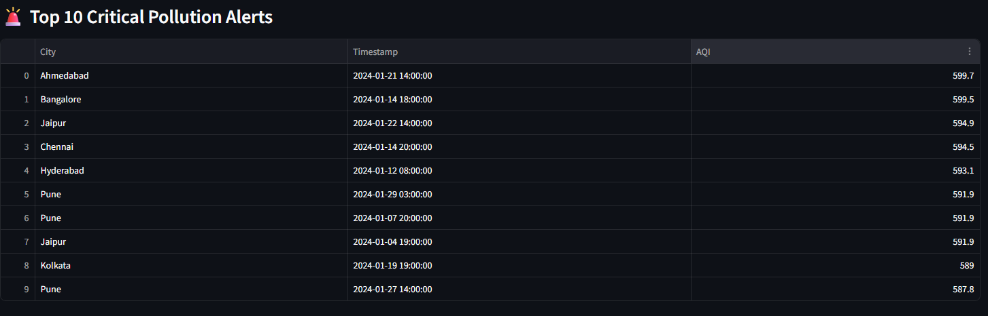

Figure 2.2: Cities with Three-Hour Critical Windows
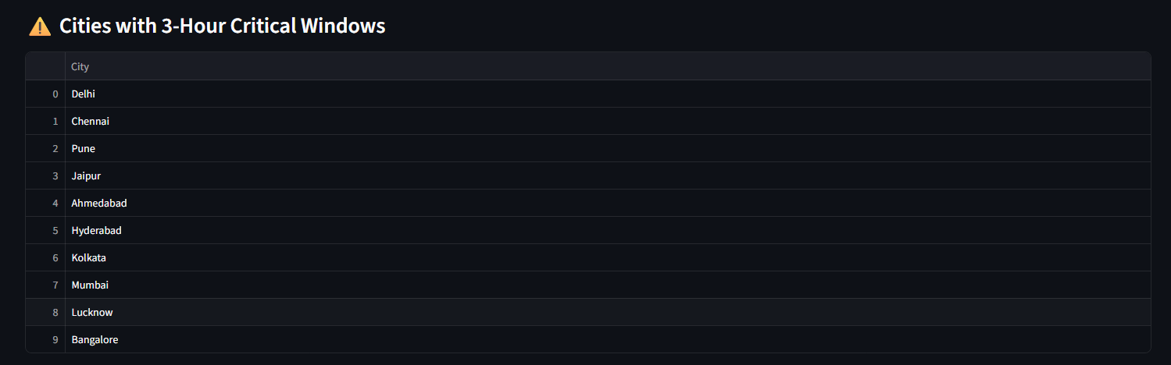

TASK 3 – Climate Dashboard (Matplotlib)
Introduction
Large environmental datasets are difficult to interpret using numerical tables alone.
To provide meaningful insights, a four-panel analytical dashboard was developed using Matplotlib.
The dashboard summarizes temporal, spatial, and categorical pollution characteristics.

Panel 1 – AQI Time Series
The first panel displays hourly average AQI for all ten cities.
Each city is represented using an independent line, enabling comparison of pollution trends throughout the observation period.
A shaded red region indicates AQI values greater than 200, highlighting hazardous pollution intervals.
This visualization helps identify:
- Daily pollution variation
- Peak pollution periods
- Inter-city comparisons

Panel 2 – Heatmap
The second panel visualizes average AQI using a heatmap.
Axes:
- X-axis → Day of Week
- Y-axis → Hour of Day
Each cell represents the average AQI for a specific day and hour.
Color intensity increases with pollution severity.
The heatmap enables quick identification of recurring pollution patterns such as morning traffic peaks or weekend pollution reduction.

Panel 3 – Grouped Bar Chart
This panel compares normalized pollutant concentrations across AQI categories.
Pollutants include:
- PM2.5
- PM10
- NO₂
- SO₂
- CO × 10
- O₃
Normalization allows pollutants with different measurement ranges to be compared fairly.
The chart highlights which pollutants dominate under different air quality conditions.

Panel 4 – Pie Chart Grid
A 2 × 5 grid of pie charts displays AQI category distribution for each city.
Each pie chart illustrates the percentage of observations belonging to:
- Good
- Satisfactory
- Moderate
- Poor
- Very Poor
- Severe
This visualization enables rapid comparison of overall air quality across all monitored cities.

Output
The climate dashboard provides a comprehensive overview of pollution behavior using multiple visualization techniques.

TASK 4 – AQI Risk Map (Folium)
Introduction
While charts provide statistical insight, they do not effectively communicate geographical pollution patterns.
Therefore, an interactive AQI Risk Map was developed using Folium.
The map enables users to visualize pollution distribution across major Indian metropolitan cities.

Folium
Folium is a Python library built on the Leaflet JavaScript framework.
It enables interactive geographic visualization directly within Python.
The project initialized a map centered on India using CartoDB Dark Matter tiles.

Circle Markers
Each city is represented by a CircleMarker.
Marker properties include:
- Radius proportional to average AQI.
- Color representing pollution severity.
- Interactive tooltip.
- Detailed popup information.
This provides an immediate visual indication of pollution intensity.

Popups
Clicking on a city marker displays:
- City Name
- Average AQI
- AQI Category
- Worst Pollutant
- Rush Hour AQI
- Off-Peak AQI
- AQI Difference
These popups provide comprehensive city-level environmental information.

HeatMap
The HeatMap layer visualizes pollution density across all observations.
Small random coordinate offsets were introduced to prevent overlapping points from hiding one another.
Brighter regions indicate greater pollution concentration.
The HeatMap helps identify pollution hotspots across India.

Feature Groups
Cities were grouped according to AQI category:
- Good
- Satisfactory
- Moderate
- Poor
- Very Poor
- Severe
Layer controls allow users to selectively enable or disable pollution categories, making map exploration more interactive and informative.

Output
The AQI Risk Map combines geographical visualization with detailed environmental analytics.
Users can interactively explore pollution conditions, compare cities, and identify pollution hotspots through markers, heatmaps, and popups.
Insert Figures
Figure 4.1: Complete AQI Risk Map
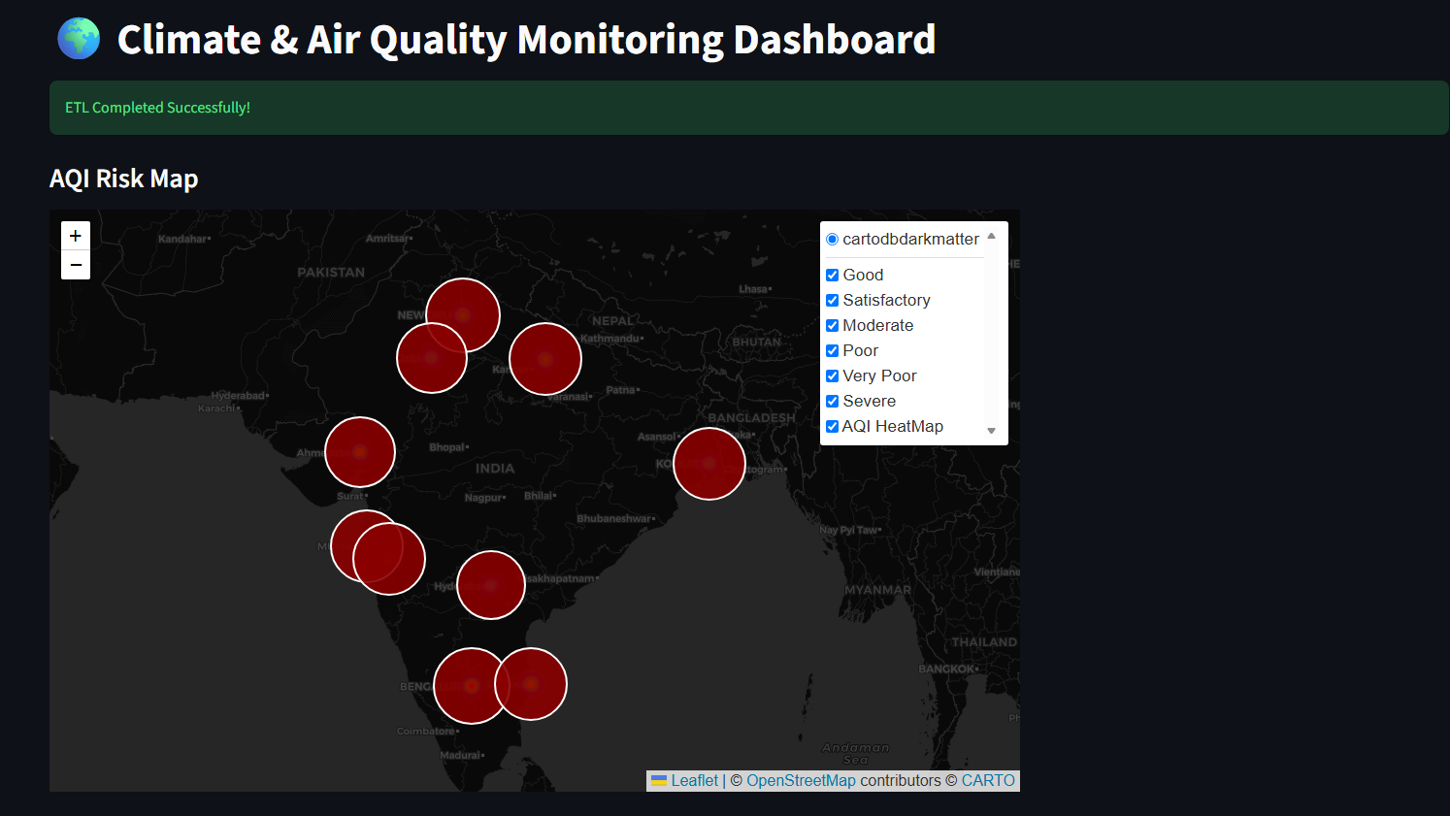

Streamlit Web Application
Introduction
To improve the accessibility, usability, and presentation of the developed Climate & Air Quality Monitoring System, the complete project was deployed as an interactive web application using the Streamlit framework. While Tasks 1–4 successfully implemented data processing, pollution alert generation, visualization, and geospatial mapping, integrating these modules into a single web-based platform significantly enhanced the user experience by allowing users to interact with the system through a graphical interface instead of executing Python scripts manually.
The Streamlit application acts as the central interface of the project, bringing together all functionalities into a unified dashboard. Users can seamlessly navigate between different modules using a sidebar menu and interact with visualizations, maps, tables, and analytical results without requiring any programming knowledge.

Dashboard Page
The Dashboard serves as the homepage of the application and provides a quick overview of the overall air quality monitoring system.
This page includes:
- Project title and description
- Key performance indicators (KPIs)
- Climate analytics dashboard generated using Matplotlib
- Summary of AQI statistics
- Overall pollution visualization
The dashboard presents the four analytical panels developed in Task 3, enabling users to understand pollution trends through a single consolidated interface.
The dashboard provides an immediate overview of:
- Average Air Quality Index
- Highest AQI observed
- Total monitored cities
- Total hourly observations
- Overall pollution trends
This page is intended to provide decision-makers with a high-level understanding of environmental conditions before exploring more detailed analyses.
AQI Risk Map Page
The AQI Map page integrates the Folium-based interactive geographical visualization developed in Task 4.
The map enables users to interactively explore pollution conditions across ten Indian metropolitan cities.
Features available on this page include:
- Interactive zoom and pan functionality
- Circle markers representing city-wise average AQI
- Color-coded pollution severity
- Dynamic popup windows containing detailed environmental information
- HeatMap layer illustrating pollution density
- Layer controls for filtering pollution categories
Each marker displays:
- City Name
- Average AQI
- AQI Category
- Dominant Pollutant
- Rush Hour AQI
- Off-Peak AQI
- Difference between Rush Hour and Off-Peak AQI
The geographical representation significantly improves environmental awareness by allowing users to identify pollution hotspots visually rather than interpreting numerical values.

Pollution Alerts Page
The Pollution Alerts page displays the output generated by the Stack and Priority Queue algorithms.
The page is divided into two primary sections.
Critical Alert Summary
The application first displays summary metrics including:
- Total Critical Pollution Alerts
- Number of Cities with Critical Pollution Windows
These metrics provide users with an immediate overview of pollution severity.
Top 10 Critical Alerts
The application displays the ten most hazardous pollution events ranked according to AQI.
Each alert contains:
- City Name
- Timestamp
- AQI Value
The Priority Queue ensures that alerts are displayed from highest to lowest severity.
Three-Hour Critical Windows
The second section lists cities that experienced three consecutive hours of AQI greater than 200.
This feature assists environmental authorities in identifying prolonged hazardous pollution conditions requiring immediate intervention.
The Streamlit interface presents these results in interactive tables, enabling users to sort and inspect the data efficiently.

Dataset Page
The Dataset page provides direct access to the cleaned air quality dataset generated after completion of the ETL pipeline.
This page displays:
- Complete cleaned dataset
- All pollutant measurements
- AQI values
- AQI categories
- Rush Hour indicator
Users can browse the processed data using Streamlit's interactive DataFrame component.
An additional download button enables users to export the cleaned dataset (daily_aqi.csv) for further analysis or reporting.
Providing direct access to the processed dataset improves transparency and enables researchers to validate analytical results independently.

Advantages of Streamlit Deployment
Deploying the project using Streamlit offers several advantages:
- Interactive user interface without requiring HTML or JavaScript.
- Easy navigation between project modules.
- Fast rendering of charts, tables, and maps.
- Integrated support for Pandas DataFrames and Matplotlib figures.
- Seamless embedding of Folium maps.
- Download functionality for processed datasets.
- Suitable for demonstration during hackathons and academic presentations.
The Streamlit interface transforms a command-line analytical project into a modern web-based application that can be easily understood by technical and non-technical users alike.

RESULTS

Overall Project Outcome
The Climate & Air Quality Monitoring System successfully fulfilled all objectives specified in the hackathon problem statement. The developed solution integrates data engineering, algorithm implementation, visualization, geographical mapping, and web deployment into a single unified platform.
The ETL pipeline effectively cleaned noisy environmental sensor data by resolving missing values, correcting inconsistent formats, removing invalid sensor readings, and computing accurate Air Quality Index values. The processed dataset served as the foundation for all subsequent analyses.
The Stack and Priority Queue implementation successfully identified hazardous pollution events and ranked them according to severity. The additional three-hour critical window detection algorithm identified cities experiencing prolonged periods of dangerous air quality.
The Matplotlib dashboard effectively summarized pollution trends through multiple analytical visualizations, while the Folium risk map enabled intuitive geographical exploration of pollution severity.
Finally, the complete system was deployed using Streamlit, resulting in an interactive web application capable of displaying datasets, analytical charts, pollution alerts, and geographical maps through a user-friendly interface.

Module Completion Status
Module | Status
Dataset Generation | Completed
ETL Pipeline | Completed
Missing Value Handling | Completed
AQI Calculation | Completed
Stack Implementation | Completed
Priority Queue Implementation | Completed
Pollution Alert Ranking | Completed
Three-Hour Critical Window Detection | Completed
Climate Dashboard | Completed
AQI Risk Map | Completed
Streamlit Web Application | Completed
CSV Export | Completed

Key Achievements
The project successfully achieved the following:
- Developed a complete ETL pipeline for noisy environmental datasets.
- Cleaned and standardized pollutant measurements automatically.
- Computed Air Quality Index for every hourly observation.
- Implemented Stack and Priority Queue without external libraries.
- Ranked pollution alerts according to AQI severity.
- Detected continuous hazardous pollution windows.
- Generated four-panel climate analytics dashboard.
- Developed an interactive Folium-based AQI Risk Map.
- Integrated all project modules into a Streamlit web application.
- Provided downloadable processed datasets for further analysis.

Future Scope
Although the current system successfully demonstrates a complete air quality monitoring pipeline, several enhancements can further improve its functionality and scalability.
Live AQI API Integration
Currently, the project uses generated hourly air quality data. Future versions can integrate live AQI APIs provided by environmental agencies or weather services to display real-time pollution information.

IoT Sensor Connectivity
The application can be connected directly to IoT-enabled environmental sensors deployed across different locations. Real-time sensor measurements can automatically update the dashboard without manual intervention.

Machine Learning-Based AQI Prediction
Historical pollution data can be used to train machine learning models capable of predicting future AQI levels.
Possible algorithms include:
- Random Forest
- XGBoost
- LSTM Networks
- Gradient Boosting
- Support Vector Regression
Predictive analytics would help authorities take preventive actions before pollution reaches hazardous levels.

Weather Forecast Integration
Weather conditions strongly influence air pollution dispersion.
Future versions can integrate:
- Temperature
- Humidity
- Wind Speed
- Rainfall
- Atmospheric Pressure
to improve AQI prediction and environmental analysis.

Automated Notification System
The system can automatically send alerts whenever AQI exceeds predefined thresholds.
Possible notification methods include:
- SMS
- Email
- Mobile Push Notifications
- WhatsApp Alerts
This feature would enable rapid dissemination of health warnings to the public.

Mobile Application
The Streamlit application can be extended into Android and iOS mobile applications, allowing users to monitor pollution conditions from smartphones and tablets.

Historical Trend Analysis
Future versions can store long-term pollution records and perform advanced trend analysis over months or years.
This would assist researchers in studying seasonal pollution variations and evaluating environmental policies.

Cloud Deployment
The application can be deployed on cloud platforms such as:
- Streamlit Community Cloud
- AWS
- Microsoft Azure
- Google Cloud Platform
Cloud deployment would enable multiple users to access the application simultaneously from anywhere.

CONCLUSIONS
Air pollution monitoring has become increasingly important due to the growing environmental and public health challenges associated with deteriorating air quality. Accurate data collection alone is insufficient unless it is accompanied by effective preprocessing, intelligent analysis, meaningful visualization, and user-friendly presentation. This project successfully addresses these requirements by developing a complete Climate & Air Quality Monitoring System that integrates multiple domains of computer science into a unified solution.
The project began by implementing a robust Extract–Transform–Load (ETL) pipeline capable of handling noisy environmental sensor data. Missing values, inconsistent pollutant formats, invalid sensor readings, abnormal spikes, and inconsistent city names were systematically corrected, resulting in a clean and reliable dataset suitable for analysis.
To identify hazardous pollution conditions, the project implemented custom Stack and Priority Queue data structures that efficiently stored, prioritized, and ranked pollution alerts according to Air Quality Index severity. Additionally, the system detected continuous three-hour hazardous pollution windows, enabling identification of prolonged exposure risks rather than isolated pollution spikes.
A comprehensive Climate Dashboard was developed using Matplotlib to summarize pollution behaviour through multiple visualizations including AQI trends, temporal heatmaps, grouped pollutant comparisons, and city-wise AQI distributions. These visualizations transformed complex numerical data into intuitive graphical insights suitable for environmental analysis.
To enhance spatial understanding, the project incorporated Folium to generate an interactive AQI Risk Map featuring color-coded city markers, pollution heatmaps, dynamic popup windows, and category-based layer controls. The map provides an intuitive geographical representation of pollution severity across major Indian metropolitan cities.
Finally, all project components were successfully integrated into an interactive Streamlit web application, providing users with a centralized platform for exploring cleaned datasets, monitoring pollution alerts, analyzing environmental trends, and visualizing geographical pollution patterns. The web interface significantly improves accessibility and demonstrates how modern data science tools can be combined to create practical environmental monitoring solutions.
Overall, the project successfully demonstrates the integration of data engineering, data structures, statistical visualization, geospatial mapping, and web application development into a single, scalable environmental monitoring platform. The modular architecture and interactive interface make the system suitable for future enhancements such as real-time data integration, machine learning-based AQI forecasting, IoT sensor connectivity, cloud deployment, and automated public alert systems, thereby providing a strong foundation for next-generation smart environmental monitoring applications.

